EXPERIMENT – 1
Roll No: 240701359 Name: Nikhil Vinayak P
Comparative study of low-code development versus traditional application development approaches.

AIM
To study and compare the Low-Code Development Approach with the Traditional Application Development Approach based on development process, coding effort, development speed, flexibility, cost, scalability, and maintenance.

INTRODUCTION TO TRADITIONAL APPROACH
Traditional application development is the conventional method of software development in which developers write the entire application using programming languages such as Java, Python, C#, C++, or JavaScript. The application is built from scratch by designing the architecture, writing source code, testing, debugging, and deploying the software.
This approach provides complete control over the application's functionality, security, and performance. However, it requires experienced developers, longer development time, and higher development costs.

Features
- Requires extensive programming knowledge
- Manual coding for all functionalities
- Highly customizable
- Suitable for large-scale enterprise applications
- Longer development lifecycle
- Easier to optimize performance and security

Advantages
- Complete flexibility
- Better scalability
- High performance
- Strong security control
- Unlimited customization

Disadvantages
- Time-consuming
- High development cost
- Requires skilled programmers
- Complex maintenance

INTRODUCTION TO LOW CODE APPROACH
Low-code development is a modern software development approach that enables users to create applications using graphical interfaces, drag-and-drop components, pre-built templates, and minimal manual coding. Most application logic is generated automatically by the platform, reducing development effort.
Low-code platforms allow both professional developers and business users (citizen developers) to rapidly develop applications with minimal programming knowledge. They are widely used for workflow automation, business applications, dashboards, and internal management systems.

Features
- Visual drag-and-drop interface
- Minimal coding required
- Rapid application development
- Pre-built templates and components
- Faster deployment
- Easy integration with cloud services

Advantages
- Faster development
- Lower development cost
- Reduced coding effort
- Easy maintenance
- Quick deployment

Disadvantages
- Limited customization
- Vendor dependency
- Platform licensing cost
- Less suitable for highly complex applications

DIAGRAM FOR STAGES IN TRADITIONAL AND LOW CODE
Traditional
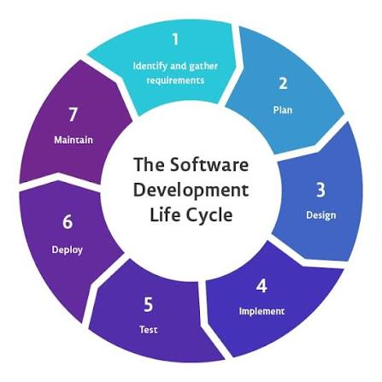
Low Code
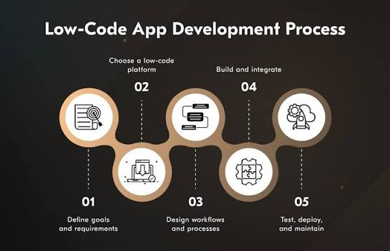
COMPARE TRADITIONAL AND LOW CODE
Feature | Traditional | Low-Code
Development | Slow | High
Coding | High | Low
Cost | Higher | Lower
Customization | Very High | Moderate
Time | Slower | Faster

